Name Rolison D. Makilan Date:2/16/2023



1. Creating new file in github

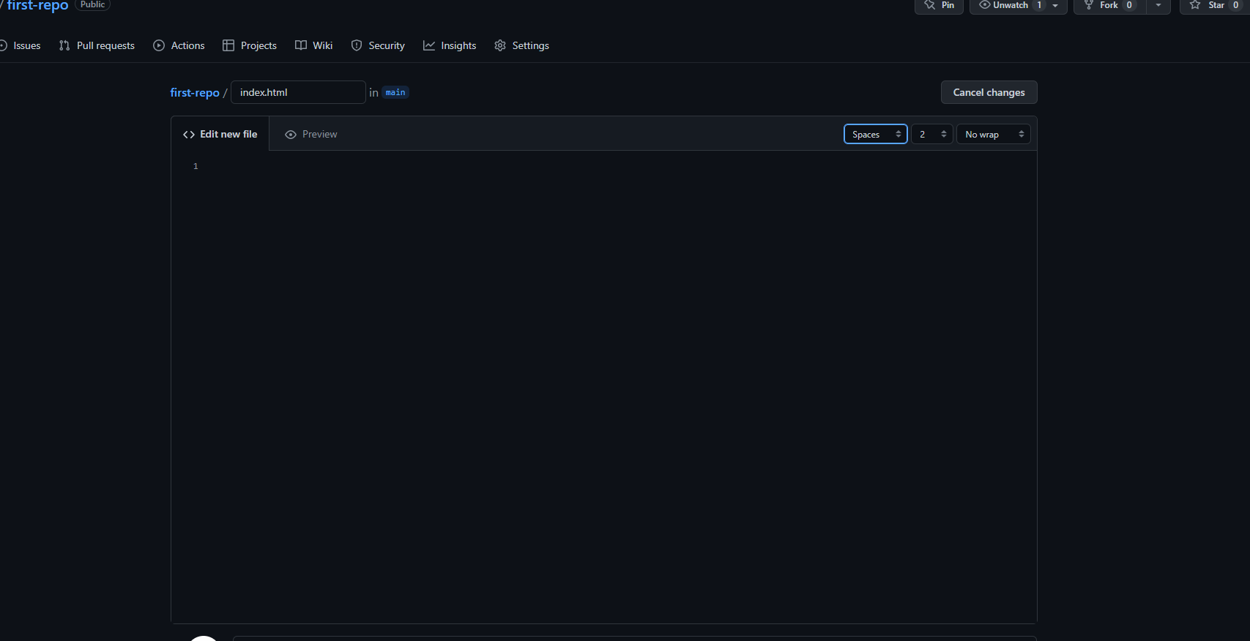

1. Updating README.md in github

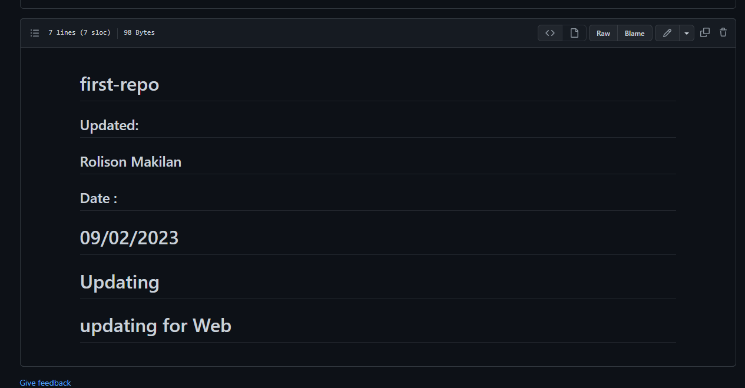

1. Git pull

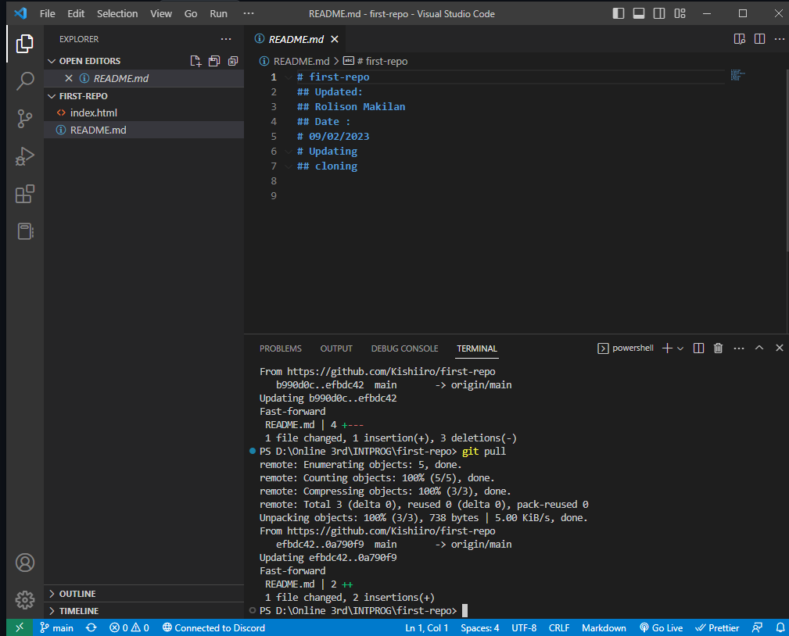

1. Conflicts on git push

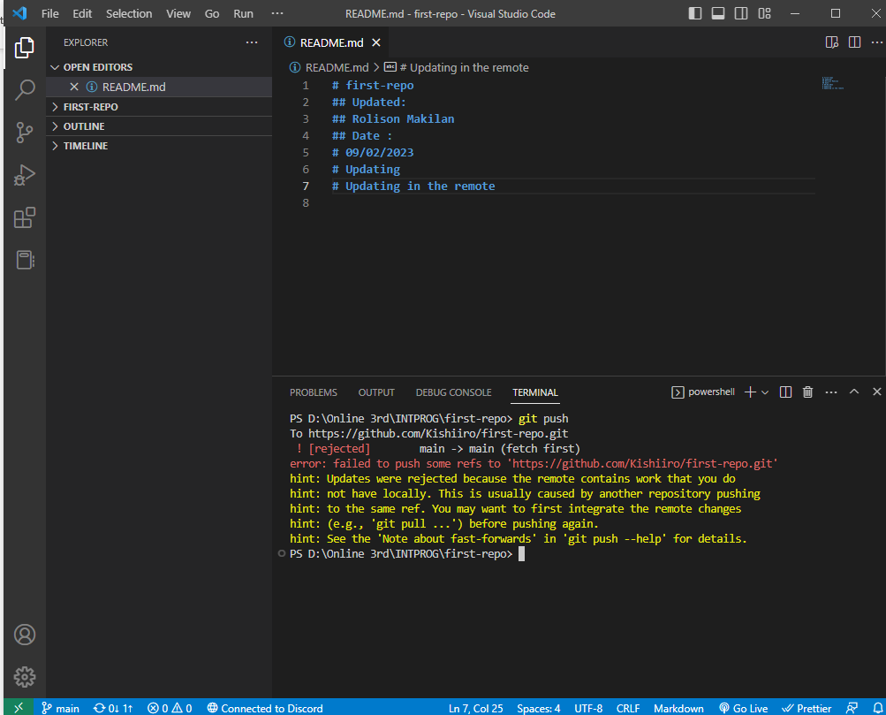

1. Git pull has been made

1. Resolving the conflicts and typed git push

1. New output with no more conflicts

